How to Make Group Work… Work

Video Workshop Link

<https://youtu.be/BIaAJi_264Y?si=a2vvL7e-dRMx0bBJ>

|  |
| --- |
| ***CONTENTS*** |

|  |  |
| --- | --- |
| Worksheet | Page 2 |
| Bloom’s Taxonomy List of Verbs | Page 3 |
| Types of Group Activities | Page 4 |
| Group Evaluation Rubric | Page 5 |

|  |
| --- |
| ***WORKSHEET*** |

|  |
| --- |
| Brainstorm and select a training situation you have encountered that could benefit from group work. |
|  |

|  |
| --- |
| Using the list of action verbs, generate 3 Learning Outcomes for the training situation you came up with. (For best results, aim for outcomes that would not be achievable through solo work). |
| By the end of this activity, learners will… |

|  |
| --- |
| Choose an activity for your group work exercise or project. |
|  |

|  |
| --- |
| Generate clear, specific, purposeful instructions for your group activity. |
|  |

|  |
| --- |
| Brainstorm a method by which you will keep your trainees accountable for their roles in the learning activity. |
|  |

|  |
| --- |
| ***BLOOM’S TAXONOMY LIST OF VERBS*** |

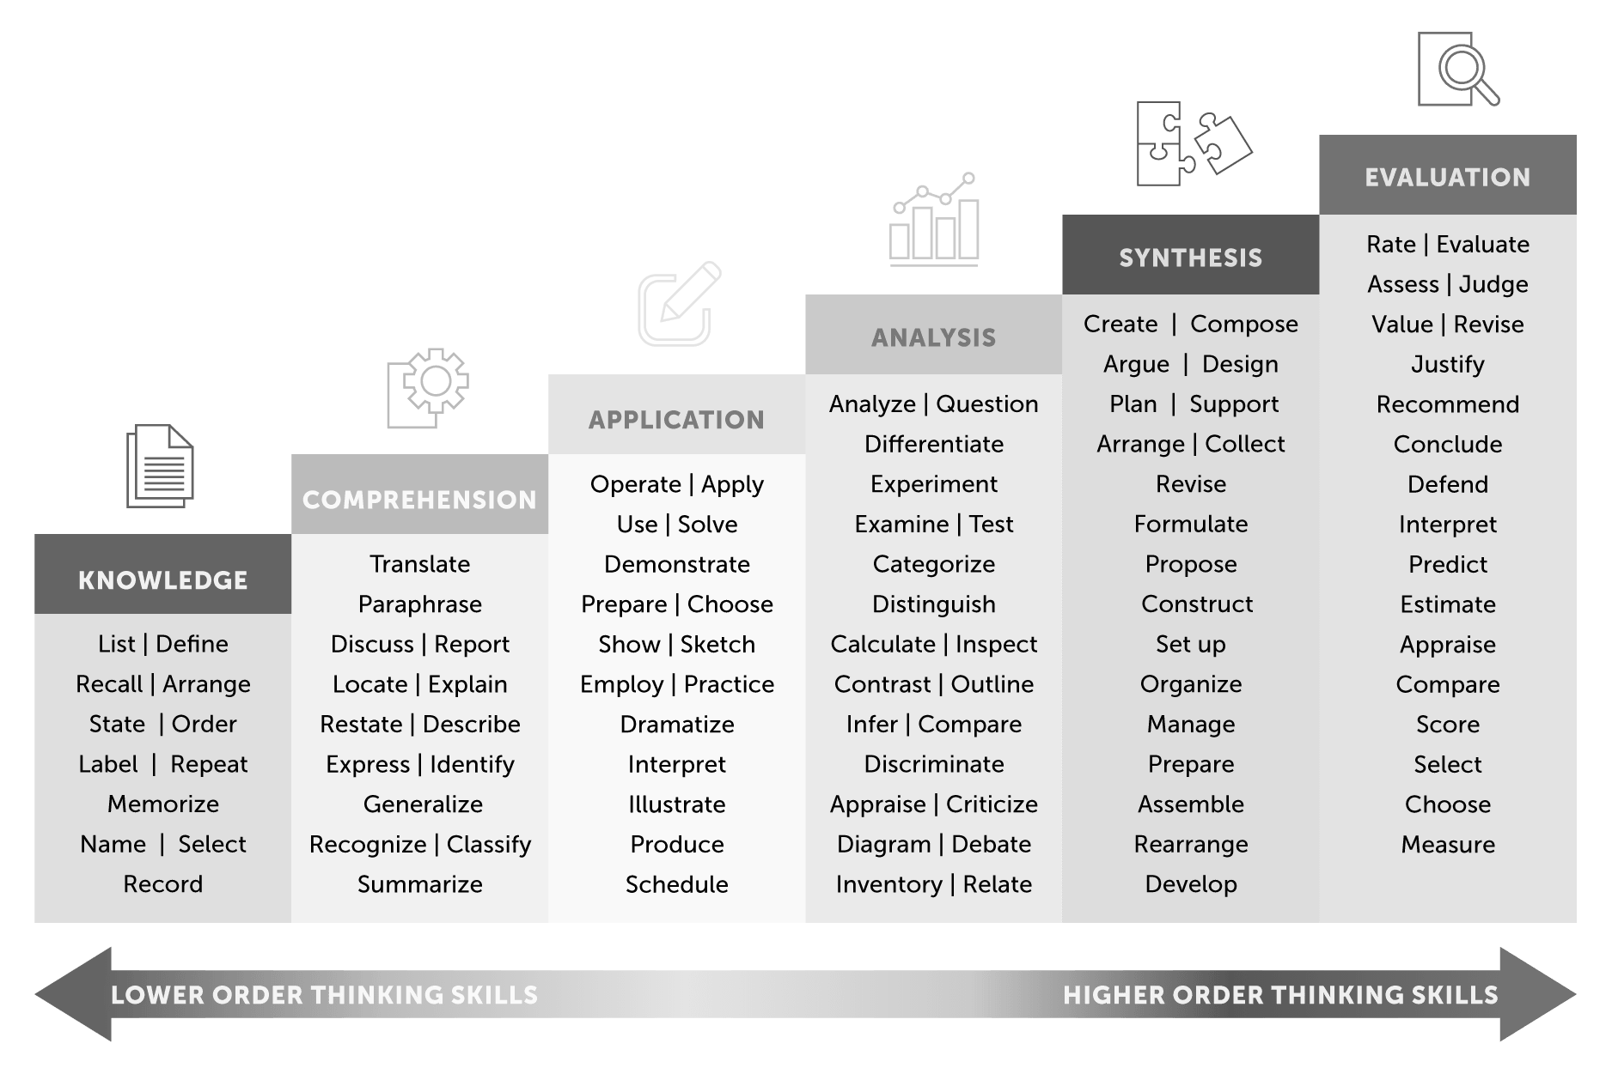

|  |
| --- |
| ***TYPES OF GROUP ACTIVITIES*** |
| **PROBLEM SOLVING** |
| The trainer presents trainees with a problem and provides scaffolding (structured guidance) toward solving the problem that emphasizes the advantages of group work. Trainees submit or present a solution. |
| **CREATION/PRODUCTION** |
| The trainer sets a task with clear and specific parameters for a deliverable. Trainees submit or present their deliverables. |
| **SCAFFOLDED DISCUSSION** |
| The trainer prepares a series of guided questions that lead trainees to specific insights, answers, or plans. For example, they can be used to help participants plan ahead for an upcoming task or think through a concept. |
| **REFLECTION / CHECK-IN** |
| The trainer stops at a transition point in the lesson. Trainees work with partners or small groups to compare notes, ask clarifying questions, or just share impressions. After a few minutes, the trainer opens the floor to crowdsourced questions OR rotates from group to group. |
| **EXCHANGES, PEER-REVIEWS, DEBATES** |
| The trainer poses a question or sets a task. Trainees work solo on the task, then share their responses with a partner or small group. Optionally, main takeaways from group discussions are shared with the entire room during a follow-up discussion. Alternatively, this activity can start with the small group scaffolded discussion and proceed to the large discussion, skipping solo work. |

|  |  |  |  |
| --- | --- | --- | --- |
| ***GROUP WORK EVALUATION RUBRIC*** | | | |
|  | **EXCELLENT** | **GOOD** | **NEEDS WORK** |
| **NECESSITY** | The material could not be taught as well without a group activity; the advantage of working as a group pertains to the activity's goals. | The activity could be carried out solo, but less effectively; OR, the advantage of working as a group could be better emphasized in the activity's structure. | The activity would be equally or more effective solo; the advantage of working as a group is not evident. |
| **STRUCTURE** | The activity is broken into scaffolded steps with clear goals or deliverables; instructions are simple and broken into parts. | The activity has clear goals and asks for a defined outcome, but instructions are complicated or insufficient. | The activity is presented as a single, complicated task, and the instructions and expectations are vague. |
| **EFFECTIVENESS** | It is clear how this activity achieves the learning outcomes, and measurable evidence can be collected. | The activity may achieve some of the learning outcomes, but it is not easy to gauge whether this is the case. | The activity asks for deliverables unconnected to its learning outcomes, or otherwise is unclear about what it’s trying to achieve. |
| **ACCOUNTABILITY** | Accountability for group members is built into the structure of the activity, without sacrificing flexibility when needed. | Additional efforts must be made to ensure student accountability; OR, the suggested accountability measures do not accommodate any flexibility. | Trainees are not adequately held accountable, and opportunities to dodge responsibilities are left open. |